**The Grapple-Shot:**

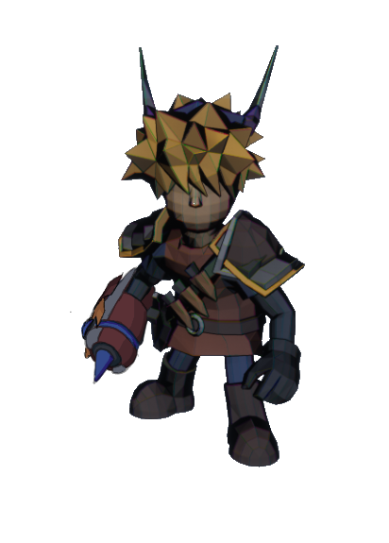

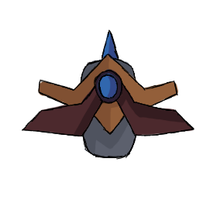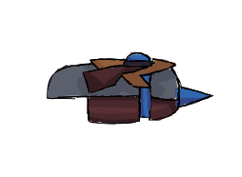

**Brief Synopsis**

The Grapple-Shot is a weapon used by the player; it acts as the long-range weapon of the game. Of all weapons the grapple-shot has the largest range, this is countered by its exceptionally narrow arc of attack only attack enemies directly in front of the player. The main use for the grapple however is its ability to pull either an enemy too the player or pull the player to an enemy.

**Usage**

**Extended Jab:**

This is a **Grounded** attack performed while the player is **Moving**, it functions as thought the player is swinging the gauntlet and firing it at the peak of its arc (forward). This will send a ranged projectile directly in front of the player attacking the first enemy it encounters.

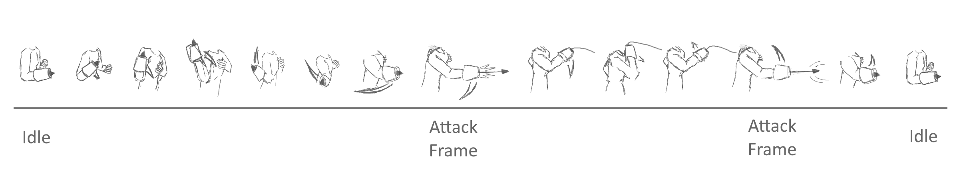

**Extended Tether:**

This is a **Grounded** attack performed while the player is **Stationary**. It functions like the extended Jab attack however if it latches onto an enemy the enemy will be pulled towards the player, stopping just before they reach them. If the player presses attack during the frames the enemy is moving towards the player, they will instead be pulled completely to the player and the player will follow there attack up with a kick.

**Whipcrack:**

This is an **Aerial** based attack that is performed while the player is attacking airborne. The player shoots upwards and pulls the cord of the grapple down attacking all enemies within the forward direction of the player.

**Special Usage:**

**Grapple:**

This has the player shoot and pull themselves to an enemy. When aerial an icon will appear over the nearest enemy within the grapples range, if the grapple button is pressed the player will grapple the enemy and pull themselves towards it. By pressing jump or attack while there being pulled forward the player will either release the grapple and jump on the enemy or kick the enemy once they reach it.